**STEP 1:**

LOGIN INTO AWS CONSOLE USING THIS : <https://console.aws.amazon.com/console/home>

Give your credentials : **[ACCOUNT ID , IAM USER NAME , PASSWORD]**

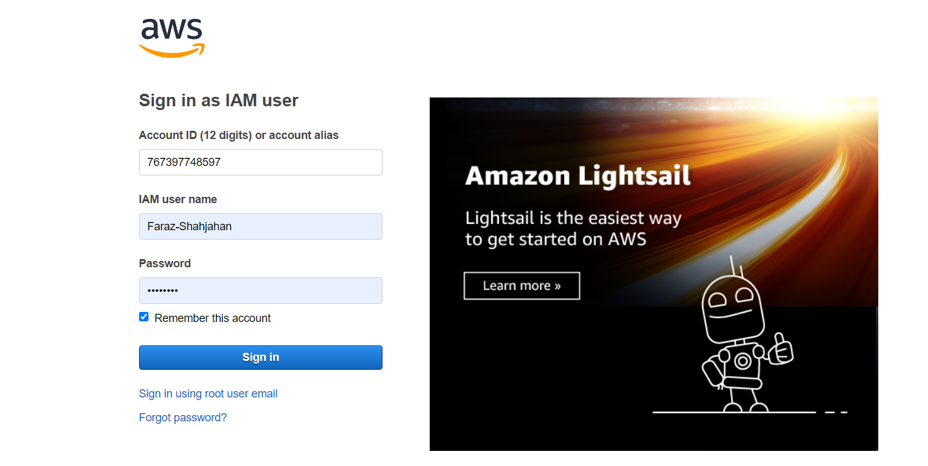

**STEP 2:**

Once logged into AWS home page search for S3 :

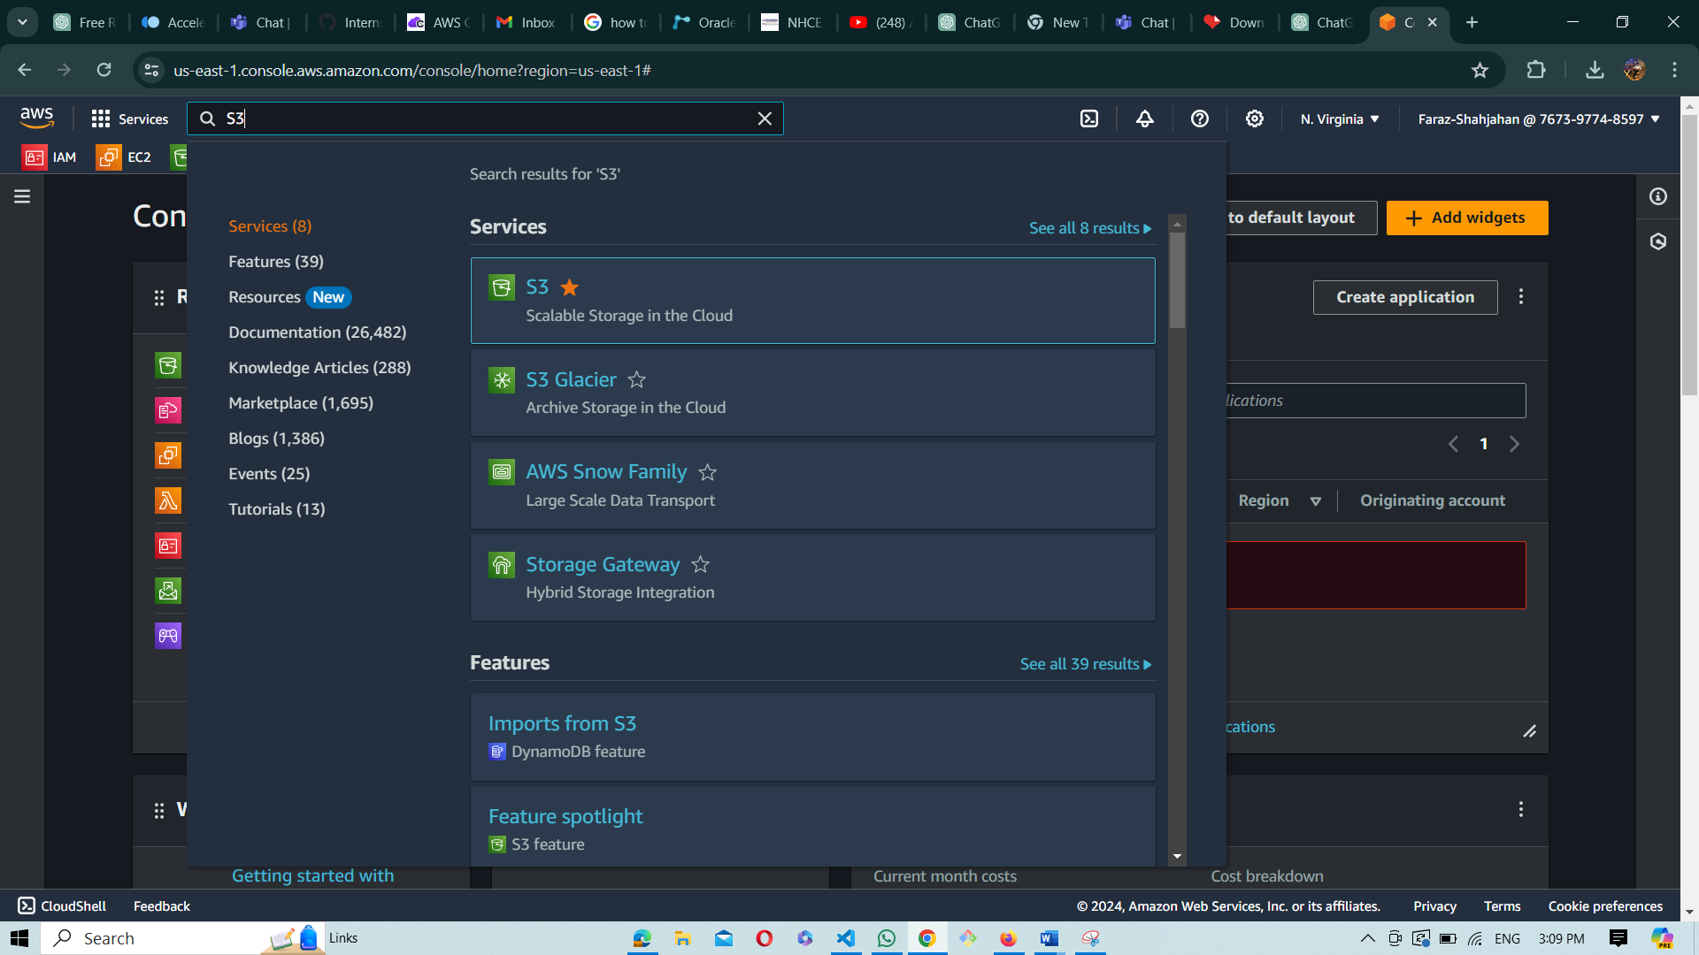

**STEP 3** : After selecting the S3 option you will be directed to **create a bucket page**

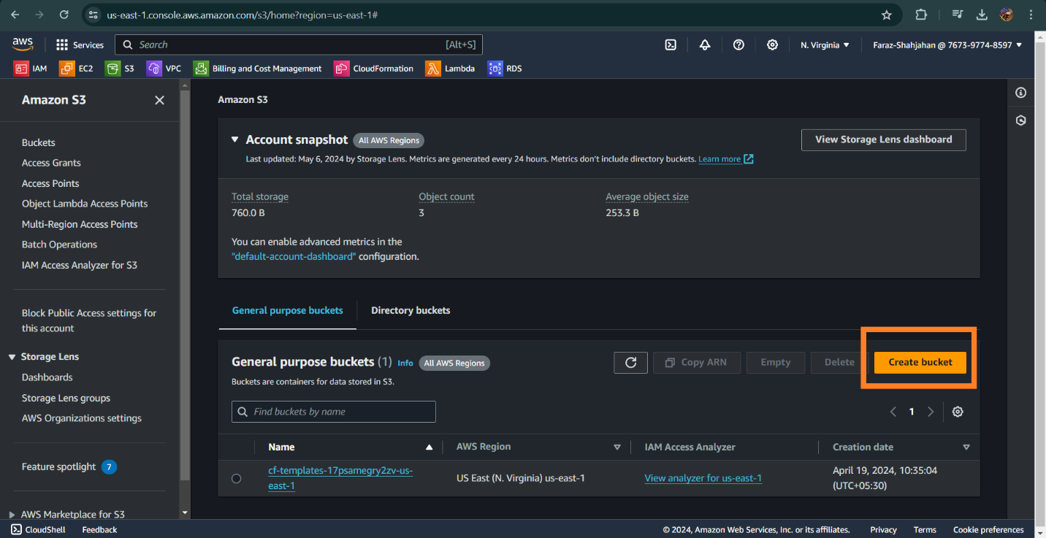

**Step 4** : After this click on the create bucket option , u have to configure the bucket as follows :

* Give bucket name : As u can see I have given the bucket name as staticweb (name can be anything of your choice) for more understanding u can refer the **rules for the bucket naming**

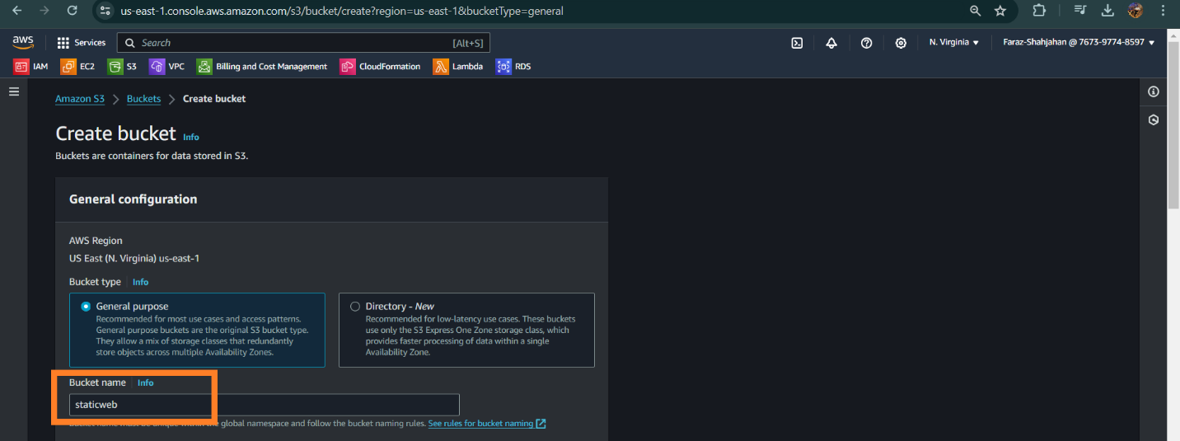

* Once done u will have to make the object ACL enabled **so that this object can also be used by other AWS user**

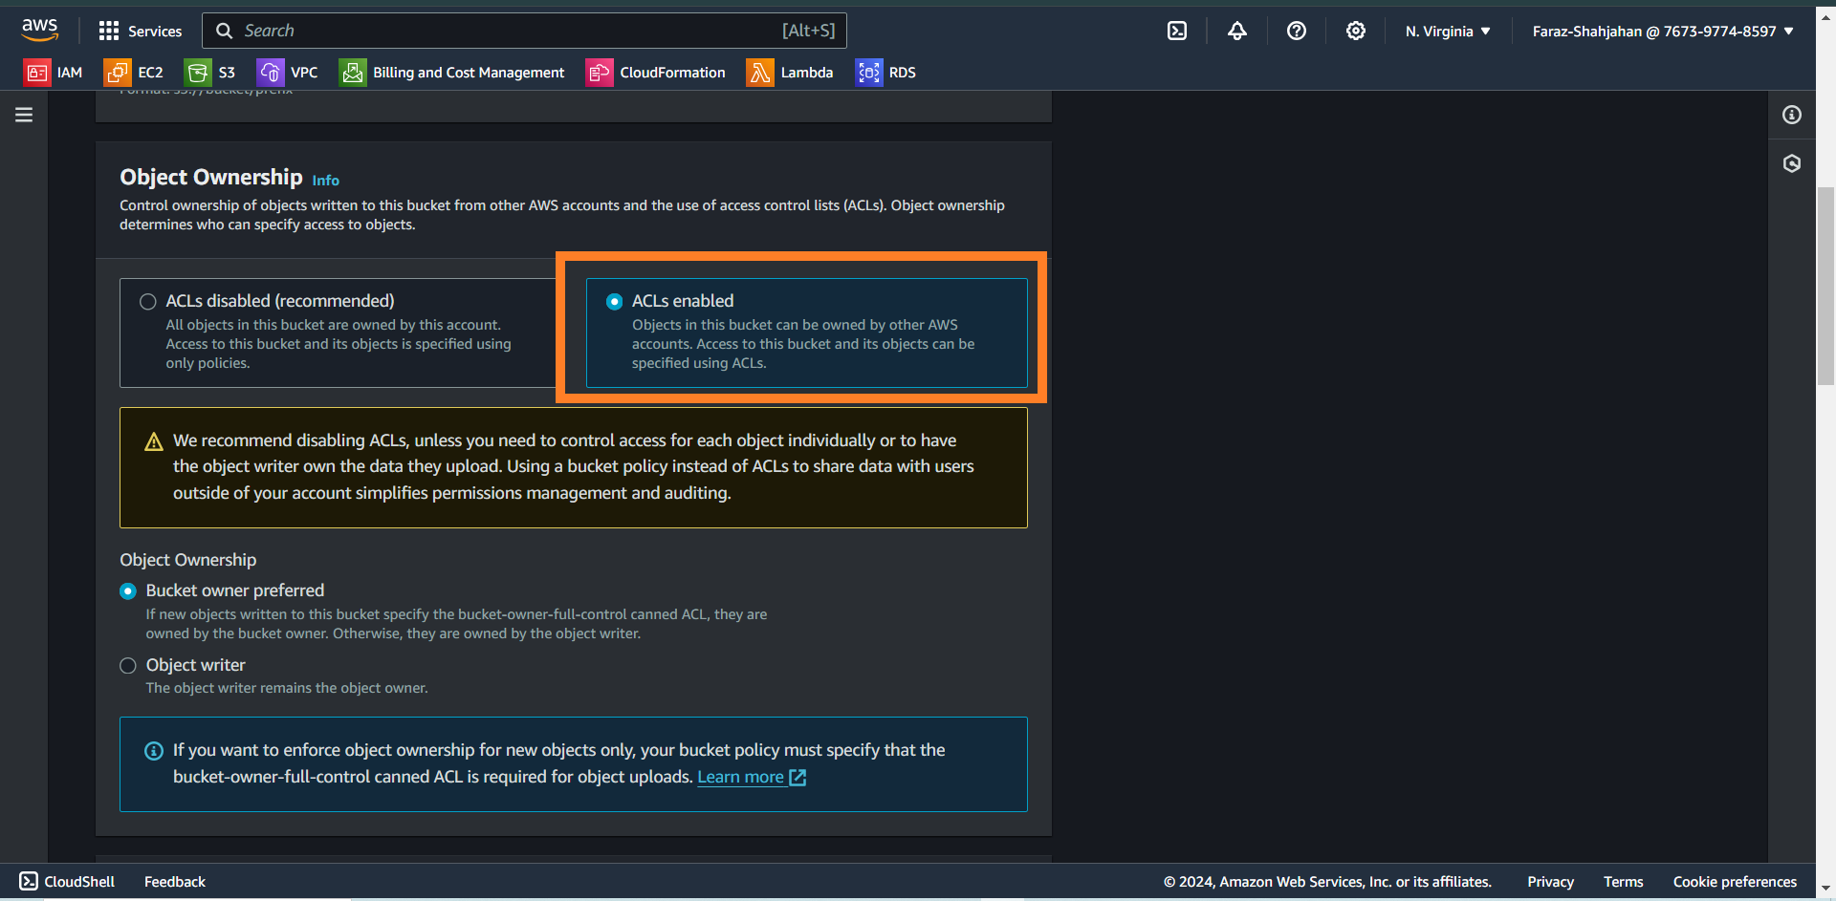

* After this to make the website public we will have to uncheck the option “block all public access” **[by default it will be checked by AWS]**

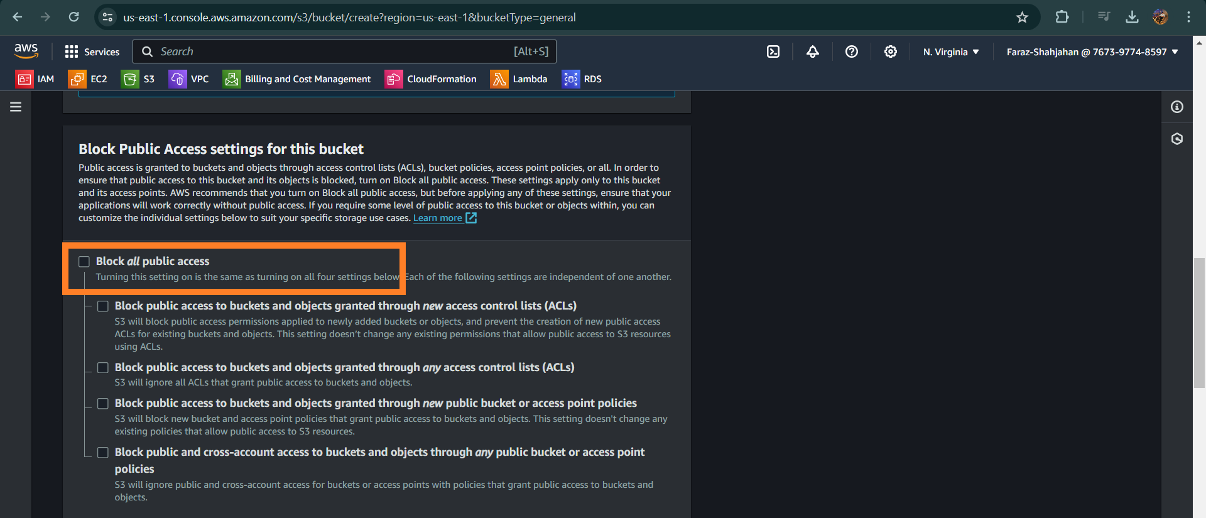

* Once this is done we also have to check an acknowledgement from AWS : Here also we will se that it will show a msg like this “ this will make the bucket public and the objects inside the bucket public”

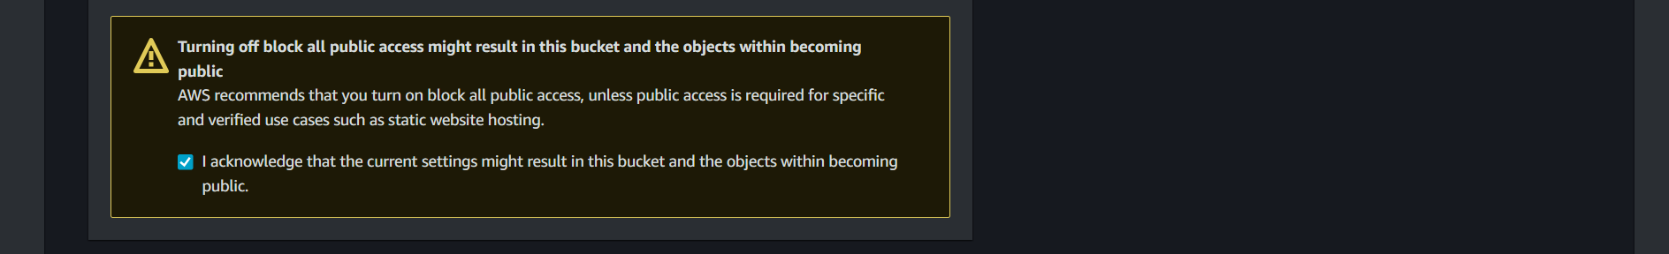

Once we configure all the bucket settings, we will see the bucket created successfully as

shown below it will also show the region in which it is created .

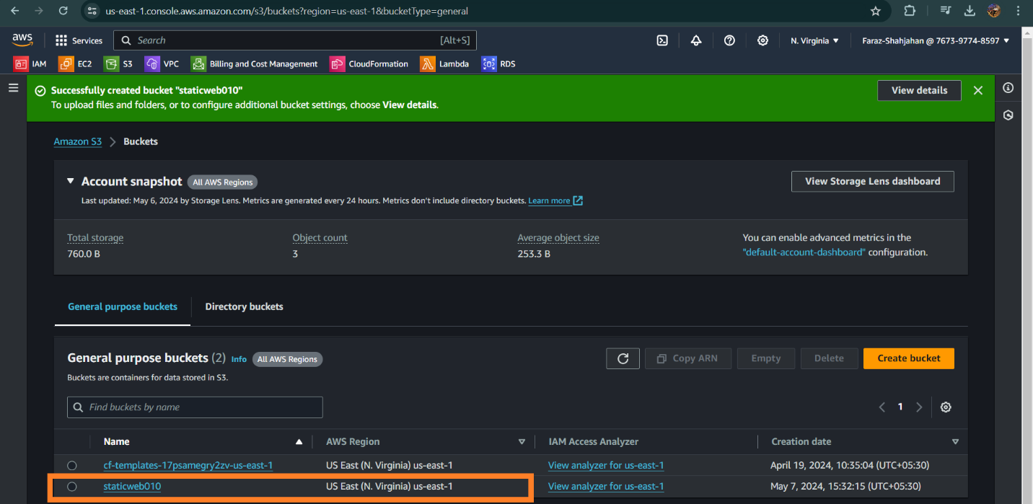

**Step 5** : Once the bucket is created we have to upload the objects inside the bucket from the page below[**To access this page click on the bucket that u created it will direct you to this page:]**

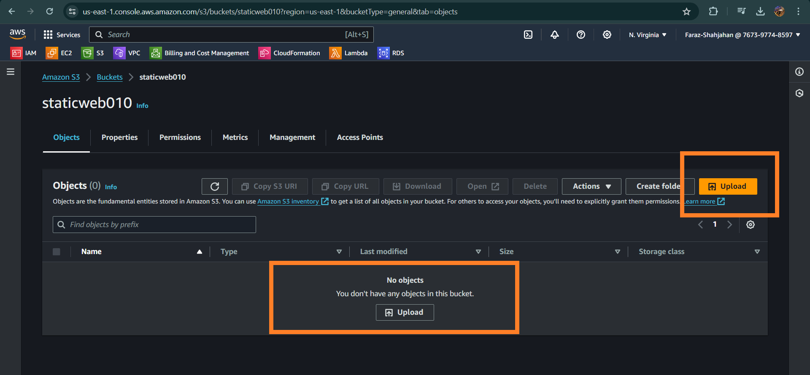

**Step 6** : Once you click on upload it will take you to this page below : As here we can see we have two options [ADD FILES] [ADD FOLDERS] , we can select any , but here as we are hosting a website we will select **Add Files.**

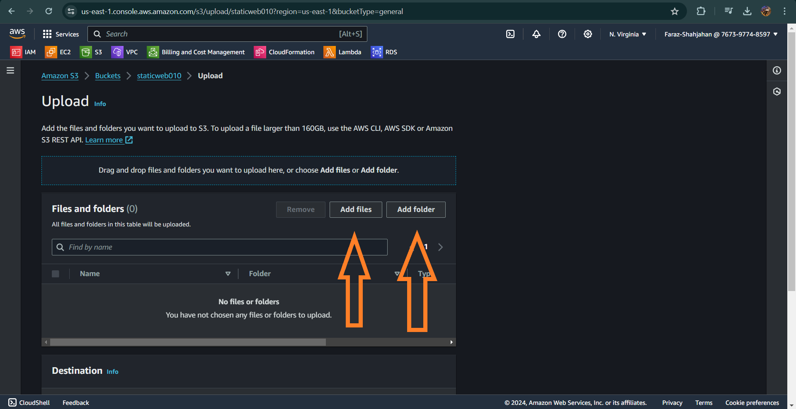

Now as we are hosting a static website we can choose any website and use the shortcut [CTRL+U] this will take to us the source page of the website that we want to host copy the entire source and make a text doc for the same and save it with .**html extension** , this same file we have to upload for hosting website.

**Step 7** : Once done AWS will direct you to upload page as shown below

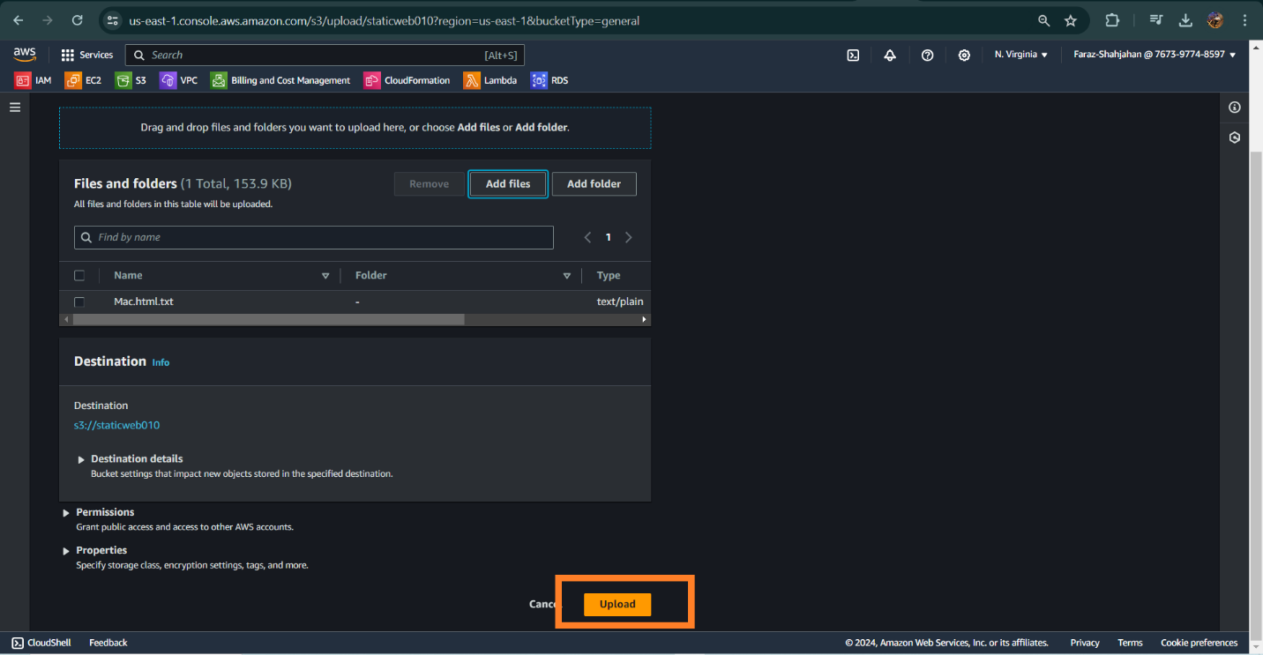

Once the upload is successful it will shown like this :

Here u can also see the text doc with .html extension which we saved.

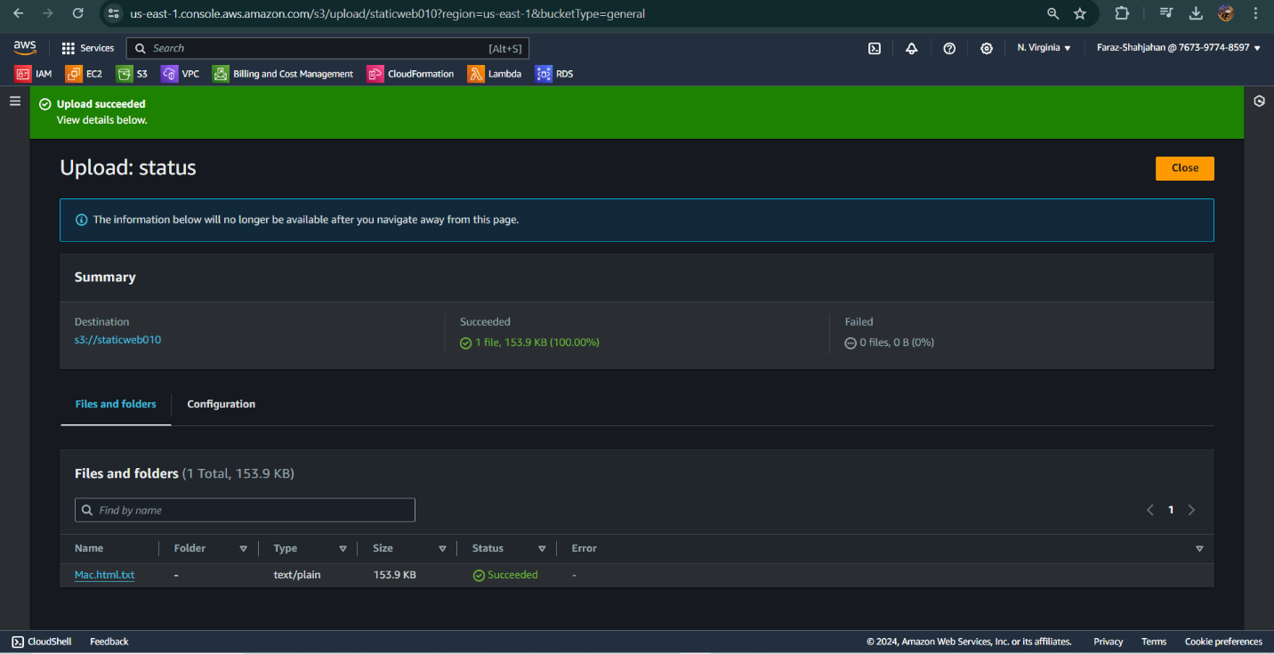

**Step 8** : Now after this when you open the object (Mac.html) it will take u to the page where u will see the properties , permission , version of the same object as shown below :

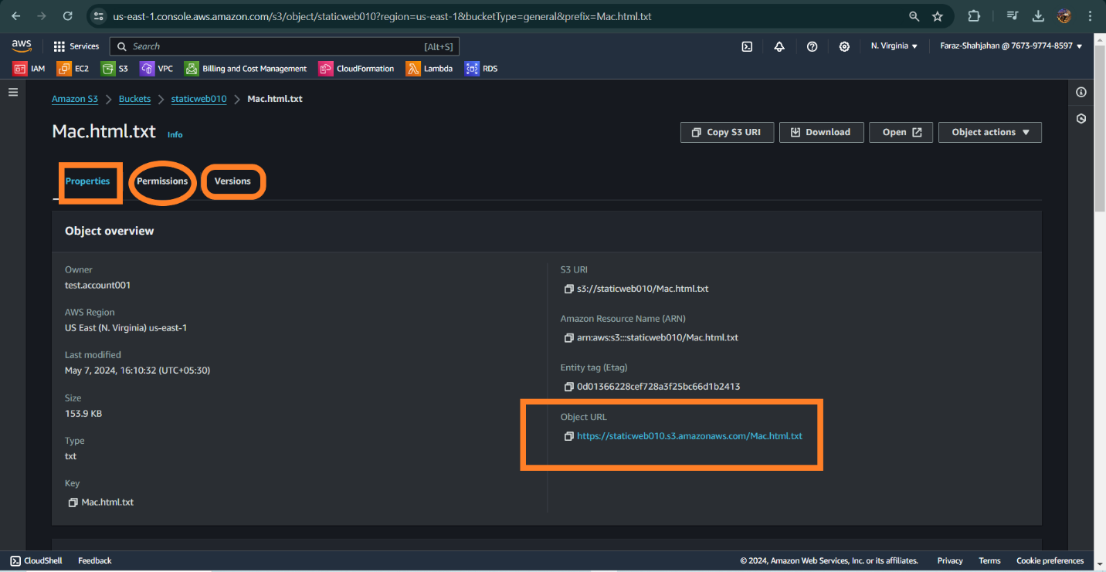

**Step 9** : Now if we want to access the website from the object URL we will not be able to do , if we access then a page will appear like this :

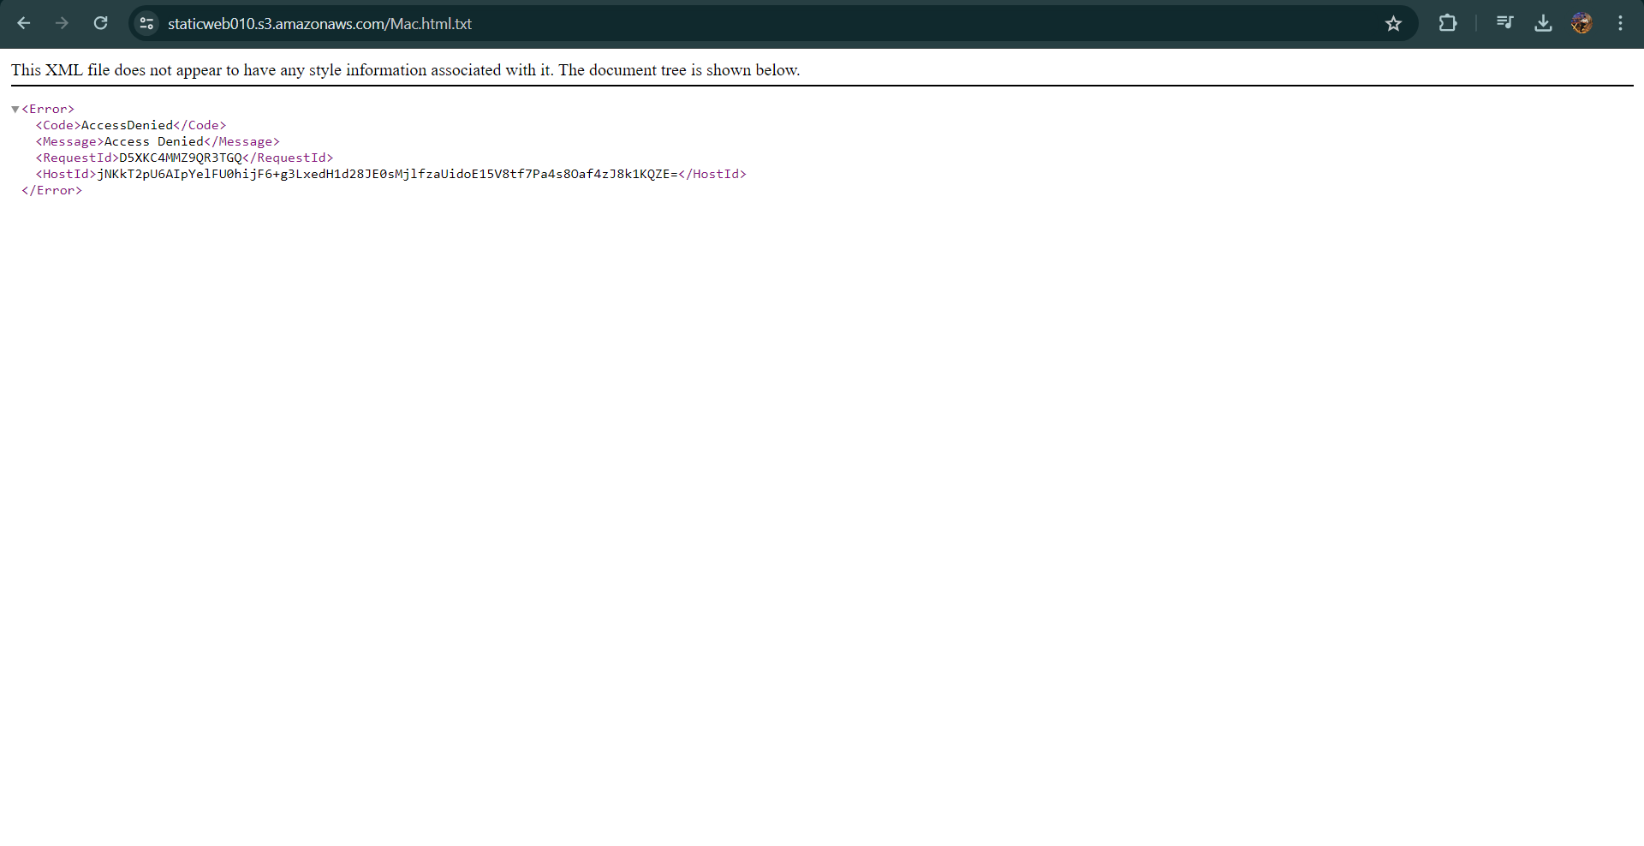

**Step 10** : To make the website access from anywhere then we have to go to Properties Sec and there is an option of Static Website Hosting we have to enable it as it defaultly disabled from AWS :

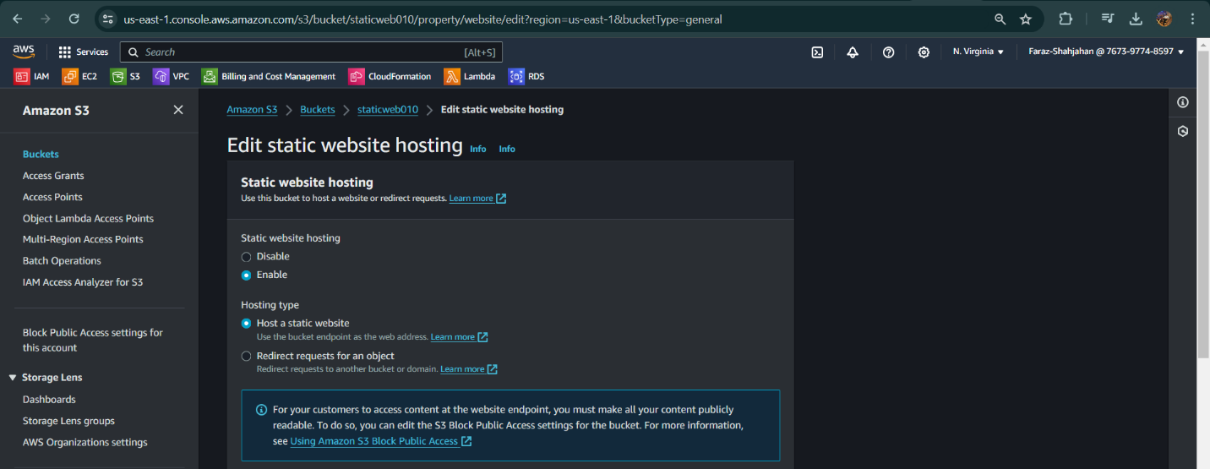

**Step 11**: Also we have to give the text doc name here as shown below (**which we saved as .html extension)** once done click on save changes.

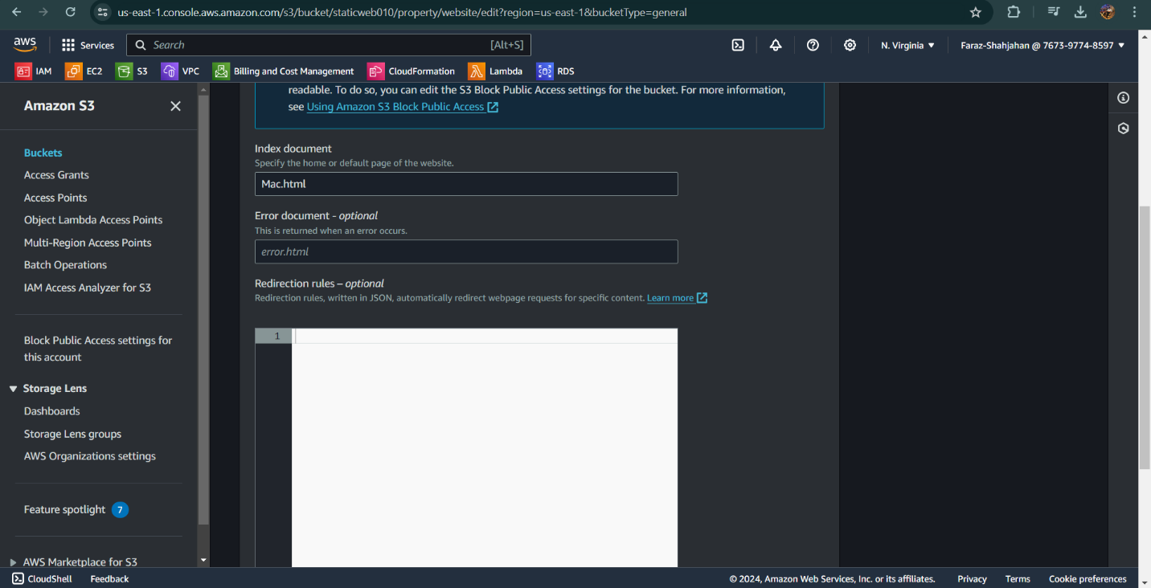

**Step 12**: Once done again come to the objects section on the top right corner u will see an option of **Actions** , select that and scroll down u will find an option of **make public using ACL** as shown below:

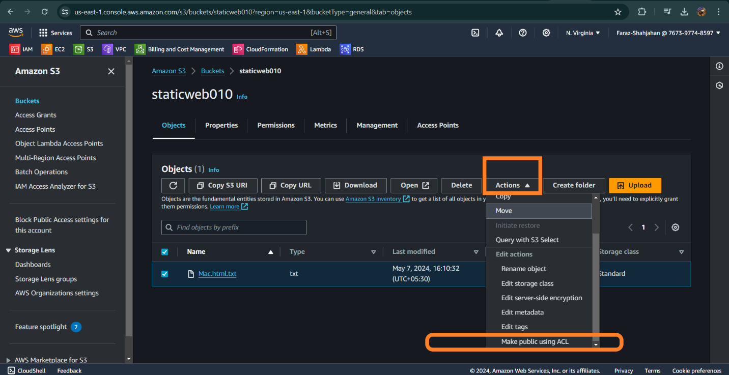

**Step 13**: Once click on Make public using ACl , it will take u the below page as shown:

